Exercise 4-1 Generative Adversarial Net

Jirayu Petchhan, D10907801

GAN model

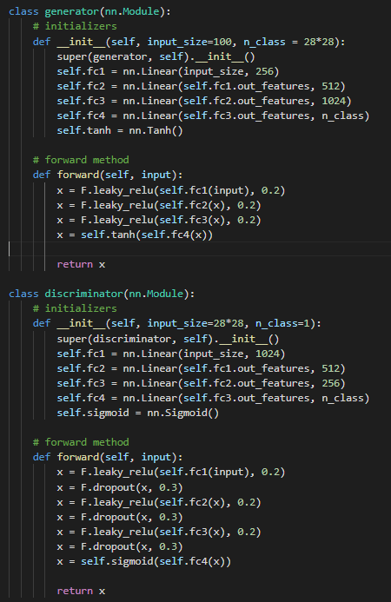

The selected optimizer and cost function (Adam and BCE loss)

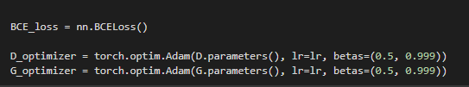

Normalized 1 channel-grayscale image and implemented FashionMNIST dataset

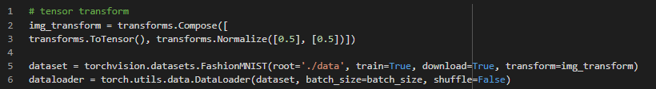

\

1. The comparation of image from different number of epochs

**n=50** epochs (default setting)

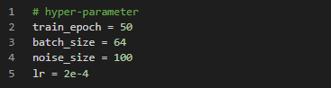

We got the final of loss of Discriminator (D) and the final of loss of Generator (G) trained on lr=2e-4 as

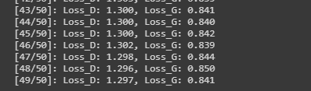

The result

|  |  |
| --- | --- |
| Number of epochs was passed | The output image |
| N=1 |  |
| N=10 |  |
| N=20 |  |
| N=30 |  |
| N=40 |  |
| N=50 |  |

Conclusion

As we see that when training has more increased the epoch round the generator can learn and be optimized from the discriminative network by BCE loss send back in the form of backpropagation.

1. The comparation of image from different number of epochs between lr= 2e-4 (existing) and lr=2e-3 (new one)

Changing learning rate to 2e-3 but setting number of epochs at the same (n=50)

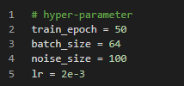

We got the final of loss of Discriminator (D) and the final of loss of Generator (G) trained on lr=2e-3 as

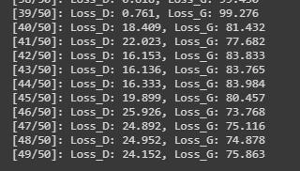

The result

|  |  |
| --- | --- |
| Number of epochs was passed | The output image |
| N=1 |  |
| N=10 |  |
| N=20 |  |
| N=30 |  |
| N=40 |  |
| N=50 |  |

Conclusion

As we changed learning rate to 2e-3, the result look worse than lr=2e-4 because the learning process of stochastic gradient has stepped too much wide that the loss cannot be improved.

1. The changing structure (latent space from 100 to 10 dimensions)

Keep learning rate from topic (2) i.e. lr = 2e-3.

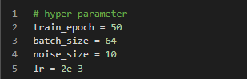

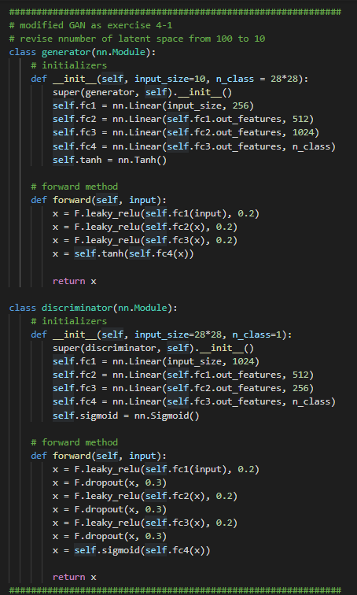

We got the final of loss of Discriminator (D) and the final of loss of Generator (G) trained on lr=2e-3 and changing structure of GAN to have input noise dimension (latent space) at 10 from 100 dimensions.

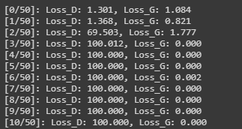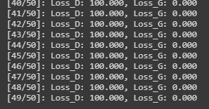

The result (N/A)

|  |  |
| --- | --- |
| Number of epochs was passed | The output image |
| N=1 |  |
| N=10 |  |
| N=20 |  |
| N=30 |  |
| N=40 |  |
| N=50 |  |

Conclusion

The result from changed structure of GAN model in the part of noise input dimensions (latent space) from 100 to 10 dims. We will see that the loss of new structure has more than the existing one (the comparation of the discriminator during the training with same learning rate i.e., at lr=2e-3) because of the reduce size of noise space which might cause of the ability of the recognition and generated image that cannot create synthetic image not as well. All of these are reason why’s loss of G cannot be increased, and loss of D cannot be decreased even though the model had been optimized in every epoch of the training.